**TITLE OF PROJECT:**

**E-COMMERCE**

MID TERM REPORT

by

**NAME OF THE CANDIDATES**

KAUSHAL BISHT (Section: K17EG) (Roll Number: 13)

ANJU RABI (Section: K17EG) (Roll Number: 14)

KOLLA NARENDRA (Section: K17EG) (Roll Number: 15)

[](https://www.google.co.in/url?sa=i&rct=j&q=&esrc=s&source=images&cd=&cad=rja&uact=8&ved=2ahUKEwjkz8H0-cbaAhUHP48KHWEIDUUQjRx6BAgAEAU&url=http://www.livelaw.in/lpus-1st-youth-vibe-national-moot-court-competition-2016/&psig=AOvVaw2hRojBLtKLfZF0zCF9iSYK&ust=1524248394115144)

**Department of Intelligent Systems**

**School of Computer Science Engineering**

**Lovely Professional University, Jalandhar**

Month-Year: APRIL 2018

**Student Declaration**

This is to declare that this report has been written by me/us. No part of the report is copied from other sources. All information included from other sources have been duly acknowledged. I/We aver that if any part of the report is found to be copied, I/we are shall take full responsibility for it.

Signature of Student

KAUSHAL BISHT

Roll number: 13

Signature of Student

ANJU RABI

Roll number: 14

Signature of Student

KOLLA NARENDRA

Roll number: 15

Place: **Lovely Professional university**

Date: **19-04-18**

**TABLE OF CONTENTS**

**TITLE PAGE NO.**

1. **Background and objectives of project assigned**  **1**

1.1

1.1.1

1.1.2

1.2

2 **Description of Project**

**BONAFIDE CERTIFICATE**

Certified that this project report “**E-COMMERCE**” is the bonafide work of “Kaushal Bisht , Anju Rabi and, Kolla Narendra” who carried out the project work under my supervision.

Signature of the Supervisor:…………………….

Name of supervisor:……………………………

Academic Designation:………………………..

ID of Supervisor:……………………………..

Department of Supervisor:……………….,,..

**Background and Objectives of the Project.** .

Objective:

To achieve a webpage on “E-Commerce “.

Containing:

* Home page
* Login form
* Registration form
* Product display page
* Cart page
* Contact us form
* About us page

Background:

Code used:

* HTML
* CSS
* JavaScript

Motivation:

Outcome of the Project:

An E-Commerce website to shop electronic gadget, clothes, footwears and extra.

Concrete goals:

**Description of Project**

REGISTERTION

LOGIN

HOME PAGE

ABOUT US

HOME

CONTACT US

PRODUCTS CATEGORY WISE

CART

PRODUCT DISPLAY DROPDOWN MENU

**Description of Work Division**

-> NAME: KAUSHAL BISHT

ROLL NO: 13

He has designed:

* HOME PAGE

* DROP DOWN MENU

*CART

-> NAME: ANJU RABI

ROLL NO.: 14

She has designed:

*ABOUT US PAGE

*CONTACT US FORM

-> NAME: KOLLA NARENDRA

ROLL NO.:15

He has designed:

*REGISTRATION FORM

*LOGIN FORM

**WORKING OF THE PROJECT**

HOME PAGE:

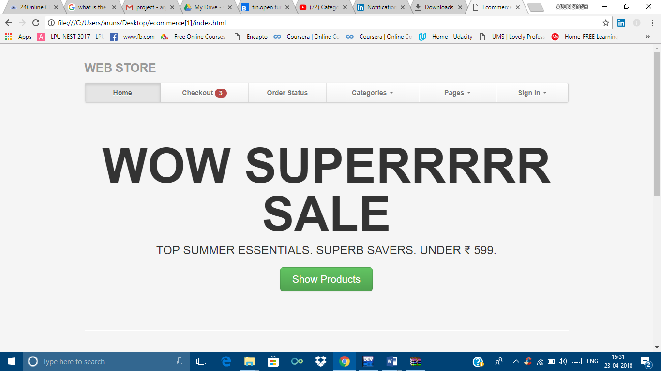

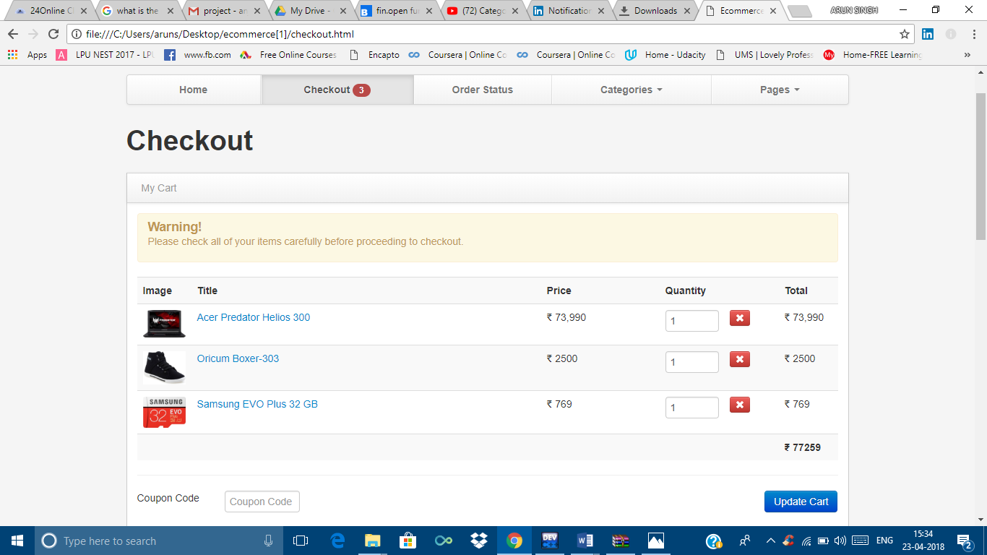

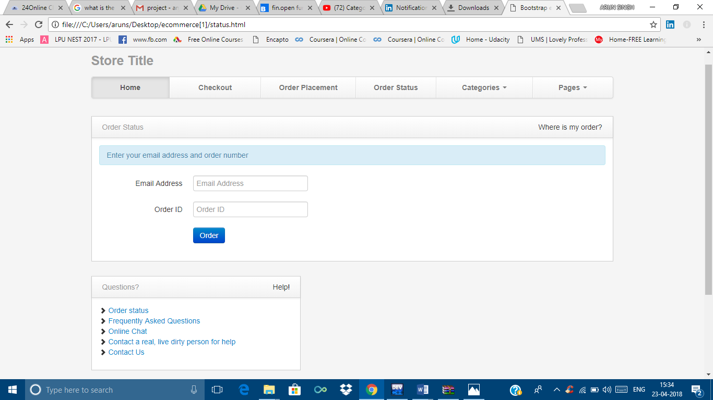

*The Home Page has a dropdown menu which are designed by using **<div>** tag.

*The contents are put into container.

*href is used for the links.

*The display format is done by the use of **CSS** file.

*The about us the link that connects you to the about us page.

HOME:



The home has a drop down list made by **<ul>** tag.

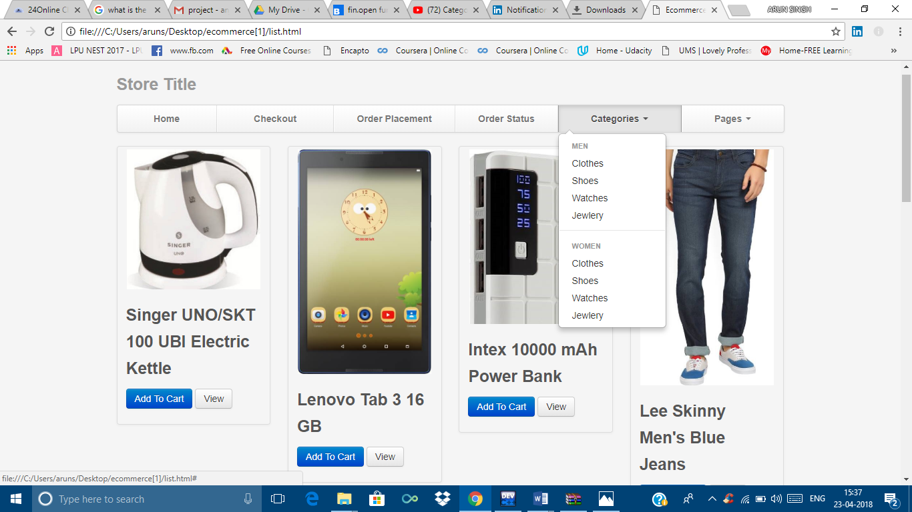

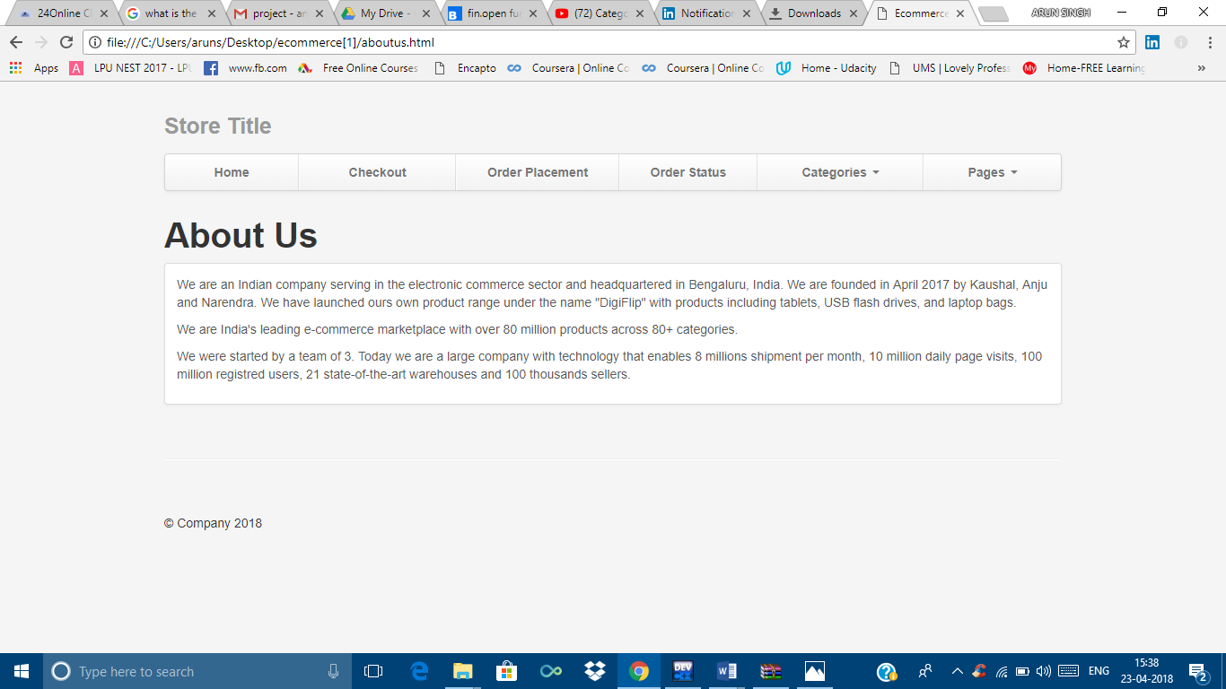

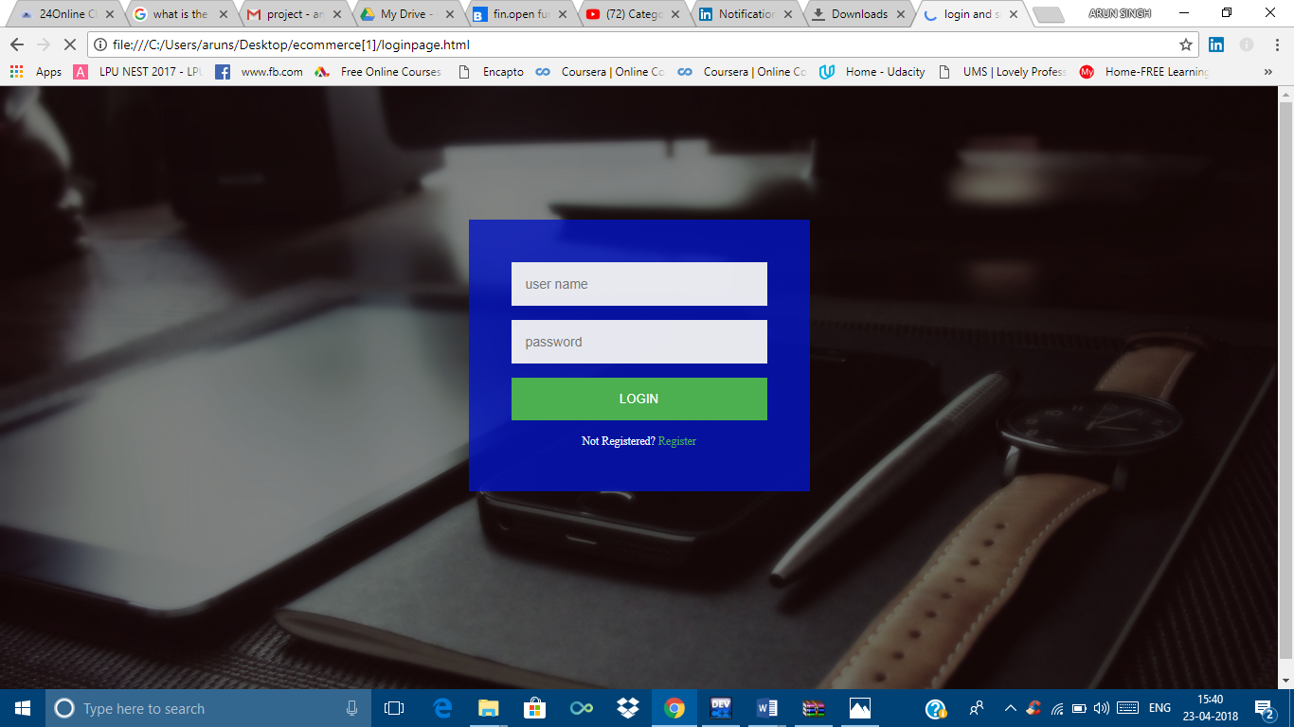

CONTACT US FORM:

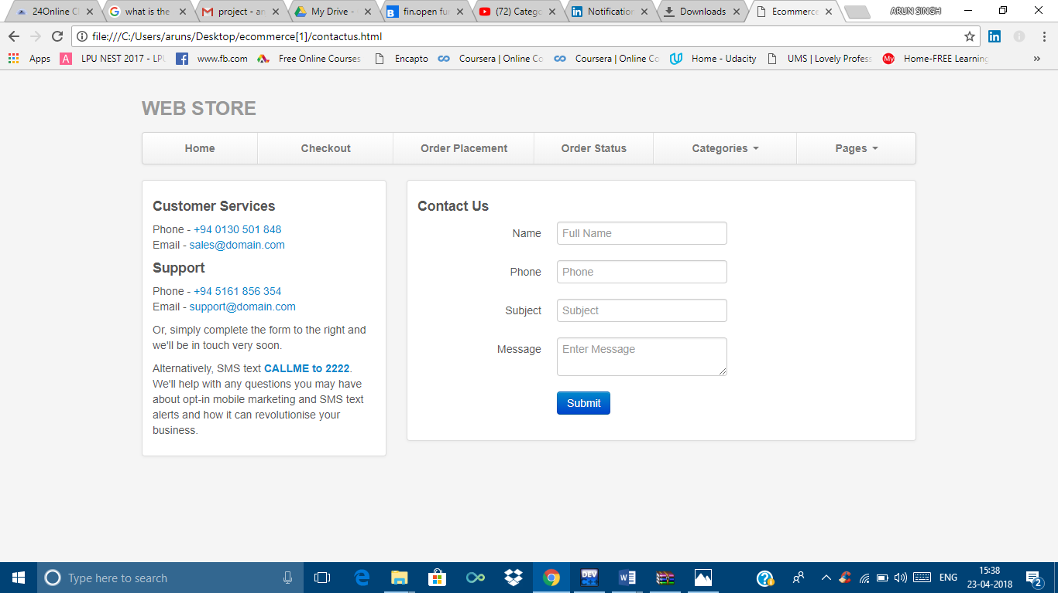

* The contact us form is made in a similar ways as the feedback form by the use of **CSS** file, **HTML**, and **JAVASCRIPT**
* The contact us page uses two containers: one to display the content and the other uses input form to get input from user.

LOGIN FORM:



**Technologies and Framework:**

**Conclusion:**

Strengths: The page provides user friendly interface.

Weaknesses: The website gives less choices for products.

Opportunities: Learnt to create a complete website.